Lab8 Sensitivity analysis of hormone model

Zhuoyang Chen 10/18/2019

**Model**

H: hypothalamic release factor P: pituitary hormone G: gonodal hormone

$$\dot{H}=\frac{1}{1+G^{n}}-k_{1}H$$

$$\dot{P}=H-k_{2}P$$

$$\dot{G}=P-k_{3}G$$

k1 = 0.15, k2 = 0.2, k3 = 0.25, and n = 9.

**Simulation**

% initial conditions

y0 **=** **[**0**;** 1**;** 1**];**

%parameters

t_end **=** 5000**;**

t_transient **=** 4500**;**

i **=** 1**;**

sensfac **=** 0.1**:**0.1**:**2**;**

t_transient defined here is for retrieving a proper value of G max and G min, since the simulation need time to reach steady state, both stable spiral and stable limit cycle, otherwise would lead to greater values of G max, smaller value of G min and thus greater value of G amplitude. sensfac is the fold factor recording change of k1, from 0.1 fold to 2 fold.

**while** i **<=** length**(**sensfac**)** %explore different k1 on G

k1 **=** sensfac**(**i**)\***k1_def**;** %from 0.1*k1 to 2*k1

options **=** odeset**(**'RelTol'**,**1e-8**);**

**[**t**,**y**]** **=** ode45**(@**HPG**,[**0 t_end**],**y0**,**options**);**

%determine max and min of G, after transient

mini **=** min**(**find**(**t **>** t_transient**));**

l **=** length**(**t**);**

maxG**(**i**)** **=** max**(**y**(**mini**:**l**,**3**));**

minG**(**i**)** **=** min**(**y**(**mini**:**l**,**3**));**

i **=** i**+**1**;**

**end**

The iteration runs through all the fold factor by an increment of 0.1. In each interation, mini records the t position when t is just after t_transient, maxG and minG finds the maximum and minimum of G values in the remaining time scale after mini.

**One-at-a-time non-local parameter analysis**

**k1 analysis**

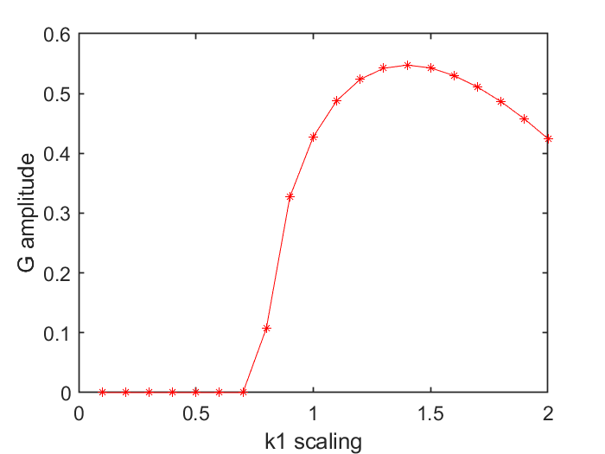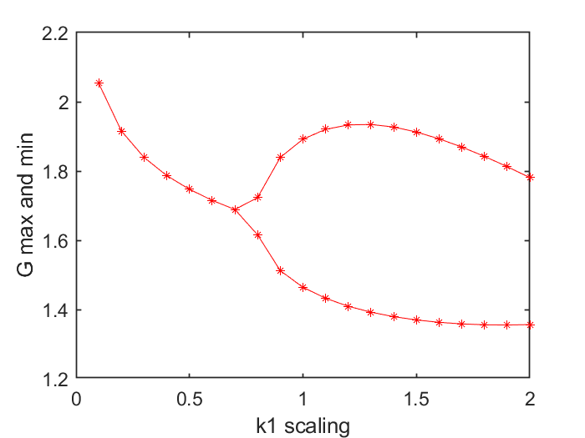 G max and min of k1 scaling G amplitude of k1 scaling

When increasing k1 from a factor of 0.1 to 2.0, the steady state value of G is decreasing (left figure). At around 0.75, a supercritical Hopf occurs, and G begins to oscillate instead of reaching fixed point. A properly increased k1 indicates faster degradation of H, which would further reduce P and G production, and in turn reduce the negative regulation by G. In the range of 0.8 (just after the bifurcation) and 1.3 of k1 factor, the positive effect of reduction in negative regulation is greater than the negative effect of degradation, thus leads to greater P and G production. After 1.3, negative effect of degradation starts to offset the positive effect, G max and G amplitude decreases.

**k2 analysis**

G max and min of k2 scaling G amplitude of k2 scaling

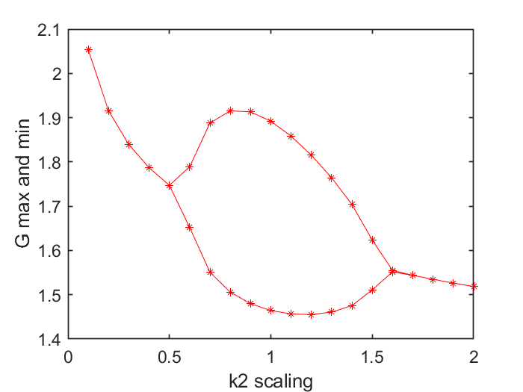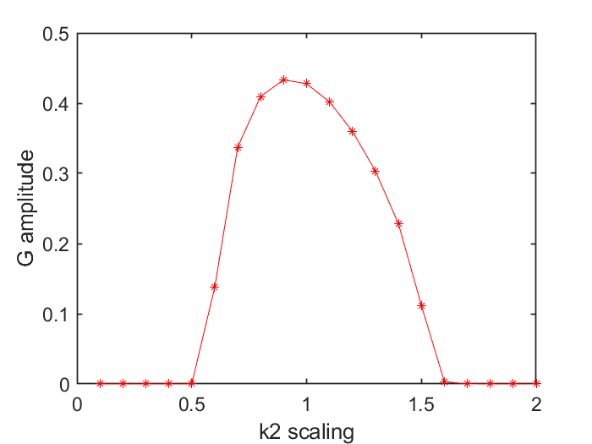

Interpretation of k2 scaling is similar to that of k1. Notice that besides a supercritical Hopf bifurcation occurs near 0.5, a subcritical Hopf bifurcation is near 1.6, indicating oscillation disappear. It’s reasonable to think that such a bifurcation would also occur in terms of k1, if we scale up the upper bound of factor from 2 to a proper value.

I extended the range to 0.1 to 3 of k1 factor, and two bifurcation points occurred.

G max and min of k1 scaling G amplitude of k1 scaling

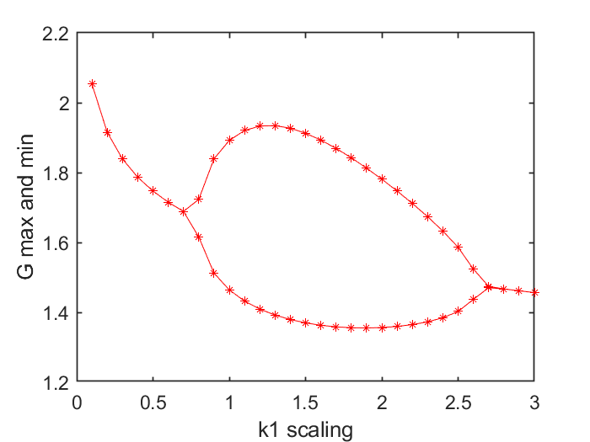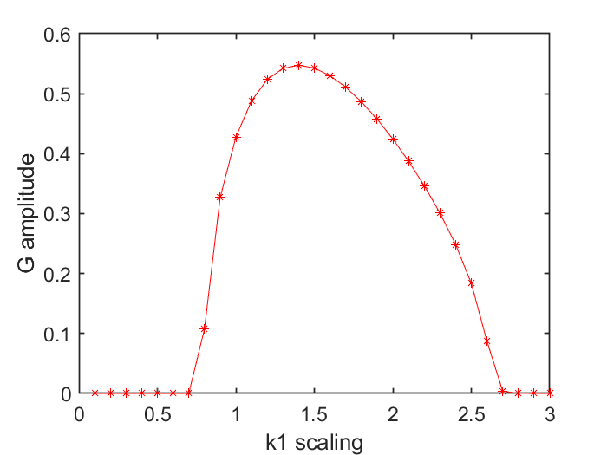

**k3 analysis**

G max and min of k3 scaling G amplitude of k3 scaling

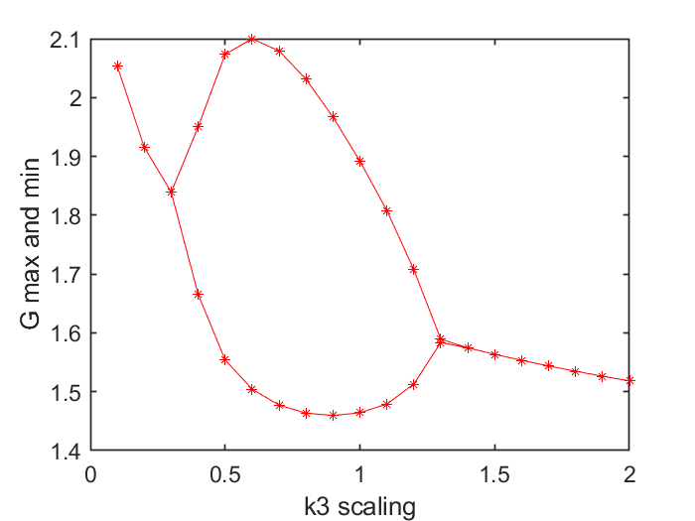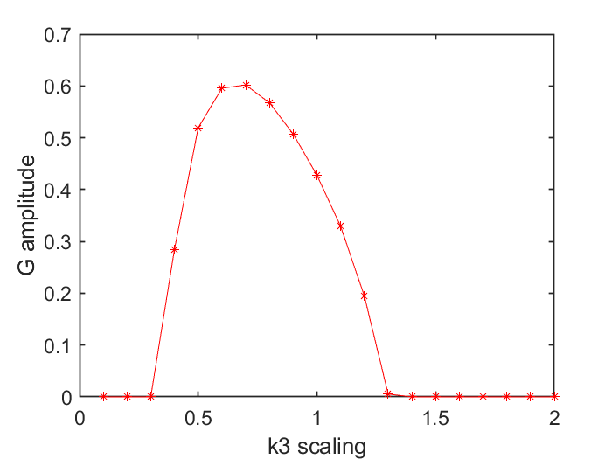

Interpretation of k2 scaling is similar to that of k1 and k2.

Putting these all together, we had:

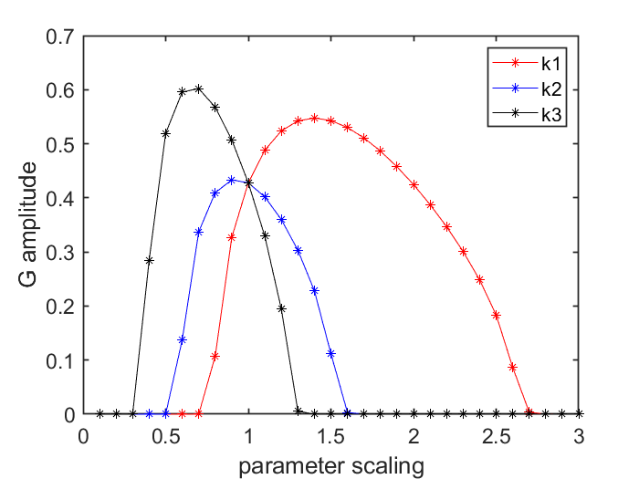

From the above, we can see that the amplitude of G mostly influenced by parameter k1 (red) and k3 (black). When k1 = 1.4, k2 = 0.9 and k3 = 0.7, amplitude of G reaches the maximum, respectively. The intersection of three curves indicates the common value of parameters at initial setting.

**Relative (local) sensitivities**

Here I used the absolute values for ranges of k1, k2 and k3. For k1, the x-axis indicates values of k1 changing from -5% to +5% around 0.15, with 0.15 sit in the middle, and the same for k2 around 0.2, k3 around 0.25.

local sensitivity of k1

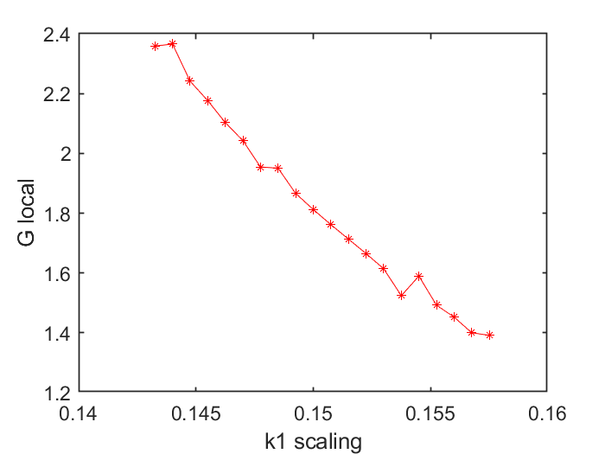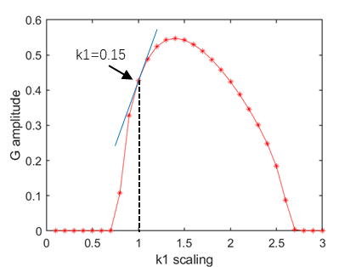

From left figure of k1, we can see that the local sensitivity is decreasing and approximately equals to 0.18 when k1 = 0.15. The positive decreasing trend means that the curve around 0.15 is approaching a local maximum. Positive values mean G amplitude is increasing, and the decreasing trend means getting closer and closer to the peak, which gives a tiny change of G amplitude. This can be illustrated in the global sensitivity figure to the right.

local sensitivity of k2

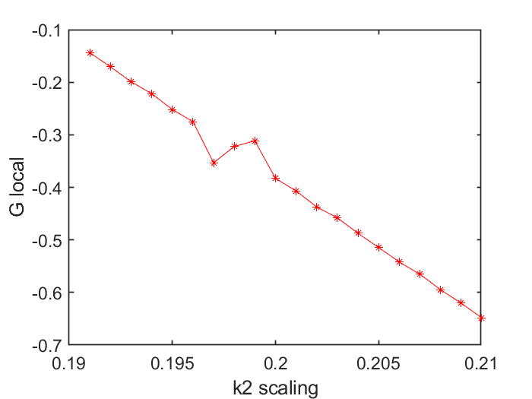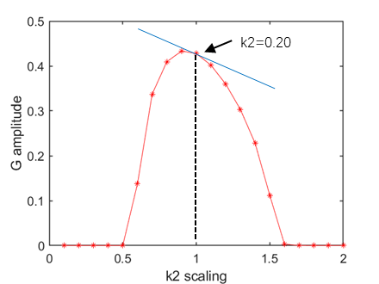

From the left figure of k2, we can see a negative increasing trend and k2 local sensitivity near -0.41. Compared to that of k1, a negative value indicates that G amplitude is decreasing, and the increasing of absolute value means the curve getting away from the local maximum. This can be illustrated in the global sensitivity figure to the right.

local sensitivity of k3

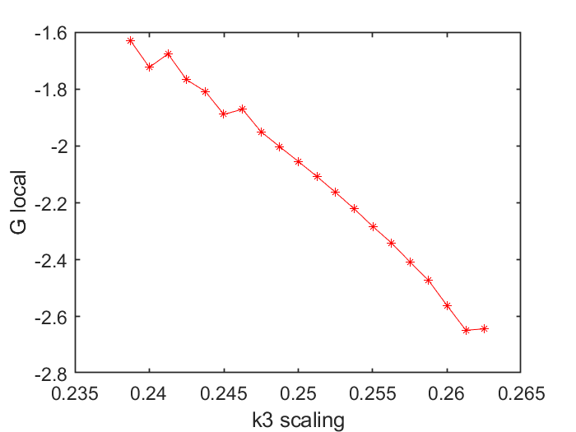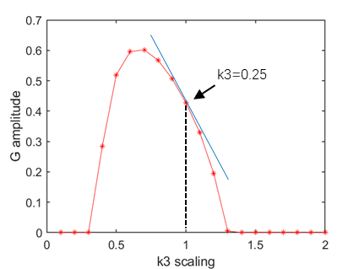

The interpretation of figure of k3 is similar to that of k2, and local sensitivity around 0.25 is near -2.05.

**Global sensitivity analysis**

I changed the while loop into for loop here, and add another for loop:

**for** i **=** 1**:**length**(**sensfaci**)** %explore different k1 on G

**for** j **=** 1**:**length**(**sensfacj**)**

k1 **=** sensfaci**(**i**)\***k1_def**;** %from 0.1*k1 to 2*k1

k3 **=** sensfacj**(**j**)\***k3_def**;**

options **=** odeset**(**'RelTol'**,**1e-8**);**

**[**t**,**y**]** **=** ode45**(@**HPG**,[**0 t_end**],**y0**,**options**);**

%determine max and min of G, after transient

mini **=** min**(**find**(**t **>** t_transient**));**

l **=** length**(**t**);**

maxG **=** max**(**y**(**mini**:**l**,**3**));**

minG **=** min**(**y**(**mini**:**l**,**3**));**

Gamp**(**i**,**j**)** **=** maxG **-** minG**;**

To find out the maximal value of G amplitude and the corresponding values of parameters pair, a few lines are required for outputs of indices:

**[**Maxi**,** Idx**]** **=** max**(**Gamp**(:));**

**[**I1**,** I2**]** **=** ind2sub**(**size**(**Gamp**),**Idx**);**

Maxi

**[**sensfaci**(**I1**),**sensfacj**(**I2**)]**

Results are shown as below:

**global analysis for k1-k2 pair**

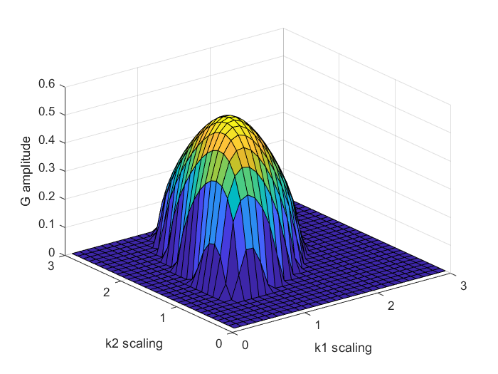

k1 = 1.20, k2 = 0.70, G_max = 0.6312

**global analysis for k1-k3 pair**

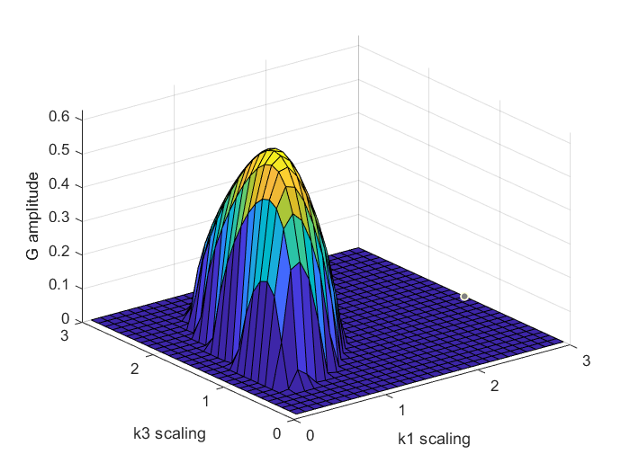

k1 = 1.50, k3 = 1.10, G_max = 0.5526

**global analysis for k2-k3 pair**

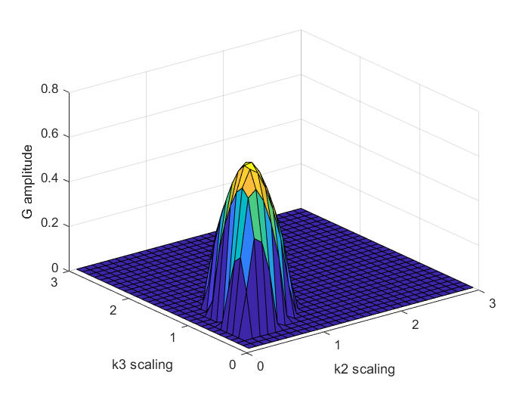

k2 = 0.70, k3 = 0.60, G_max = 0.7120

Compared to the values of k1, k2 and k3 got from one-at-a-time analysis, these results are totally different and thus could not be predicted by one-at-a-time method.